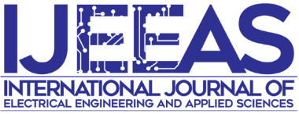

International Journal of Electrical Engineering and Applied Sciences
Center of Excellence for Robotics & Industrial Automation (CeRIA),
Faculty of Electrical Engineering, Universiti Teknikal Malaysia Melaka,
Hang Tuah Jaya, 76100 Durian Tunggal, Melaka, Malaysia
Tel: +6065552323; Fax: +605552222, E-mail: editor.ijeeas@utem.edu.my
Website: http://journal.utem.edu.my/index.php/ijeeas

TRANSFER OF COPYRIGHT AGREEMENT
Must be signed and returned to the IJEEAS before the manuscript can be considered for publication

The transfer of copyright from author to the IJEEAS must be clearly stated in writing to enable the publisher to assure maximum dissemination of the author’s work. Therefore, the following agreement, executed and signed by the main author, is required with each manuscript submission.

The manuscript entitled:
________________________________________________________________

Author’s name:
________________________________________________________________

is herewith submitted for publication in the International Journal of Electrical Engineering and Applied. The undersigned hereby warrants that the Work is original and that he/she is the author of the Work; to the extent the Work incorporates text passages, figures, data or other material from the works of others, the undersigned has obtained any necessary permissions, it has not been published before, and it is not under consideration for publication in any other journals. When the article is accepted for publication, I hereby transfer, assign, or otherwise convey all copyright ownership to IJEEAS.

Name:
Institution & Address:
Email:
Tel. No:
Date:

Signature:

________________________

